Creating a Logo in Google Drawing

- Create a new Google Document.
- Select Insert -> Drawing

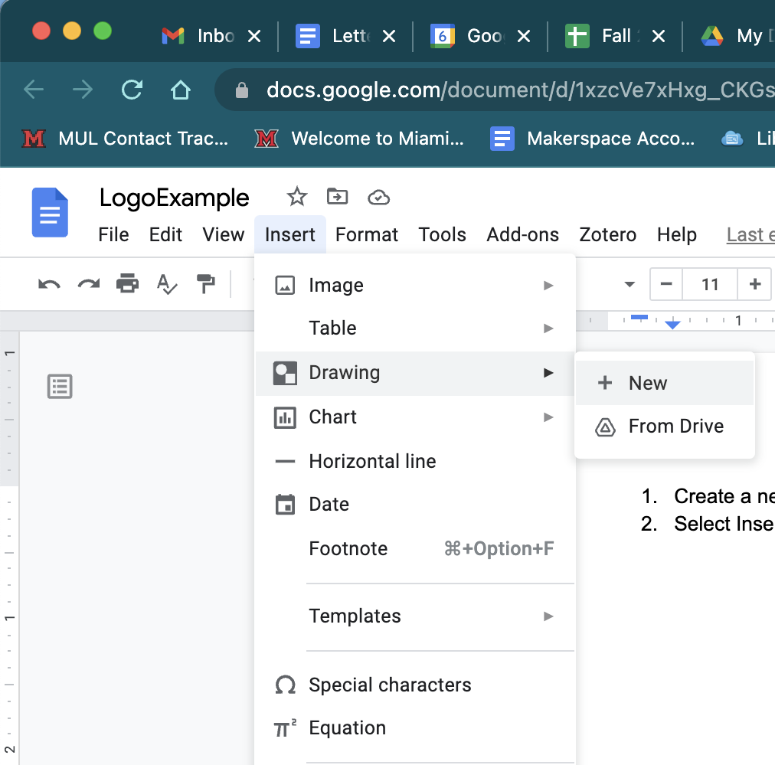
- Start your logo design with 1-3 words that describe you. Click the “T” icon to create a text box. Click and drag on the canvas to create your text box. Type in your word(s), then highlight the text and scroll through the fonts to find one you like.
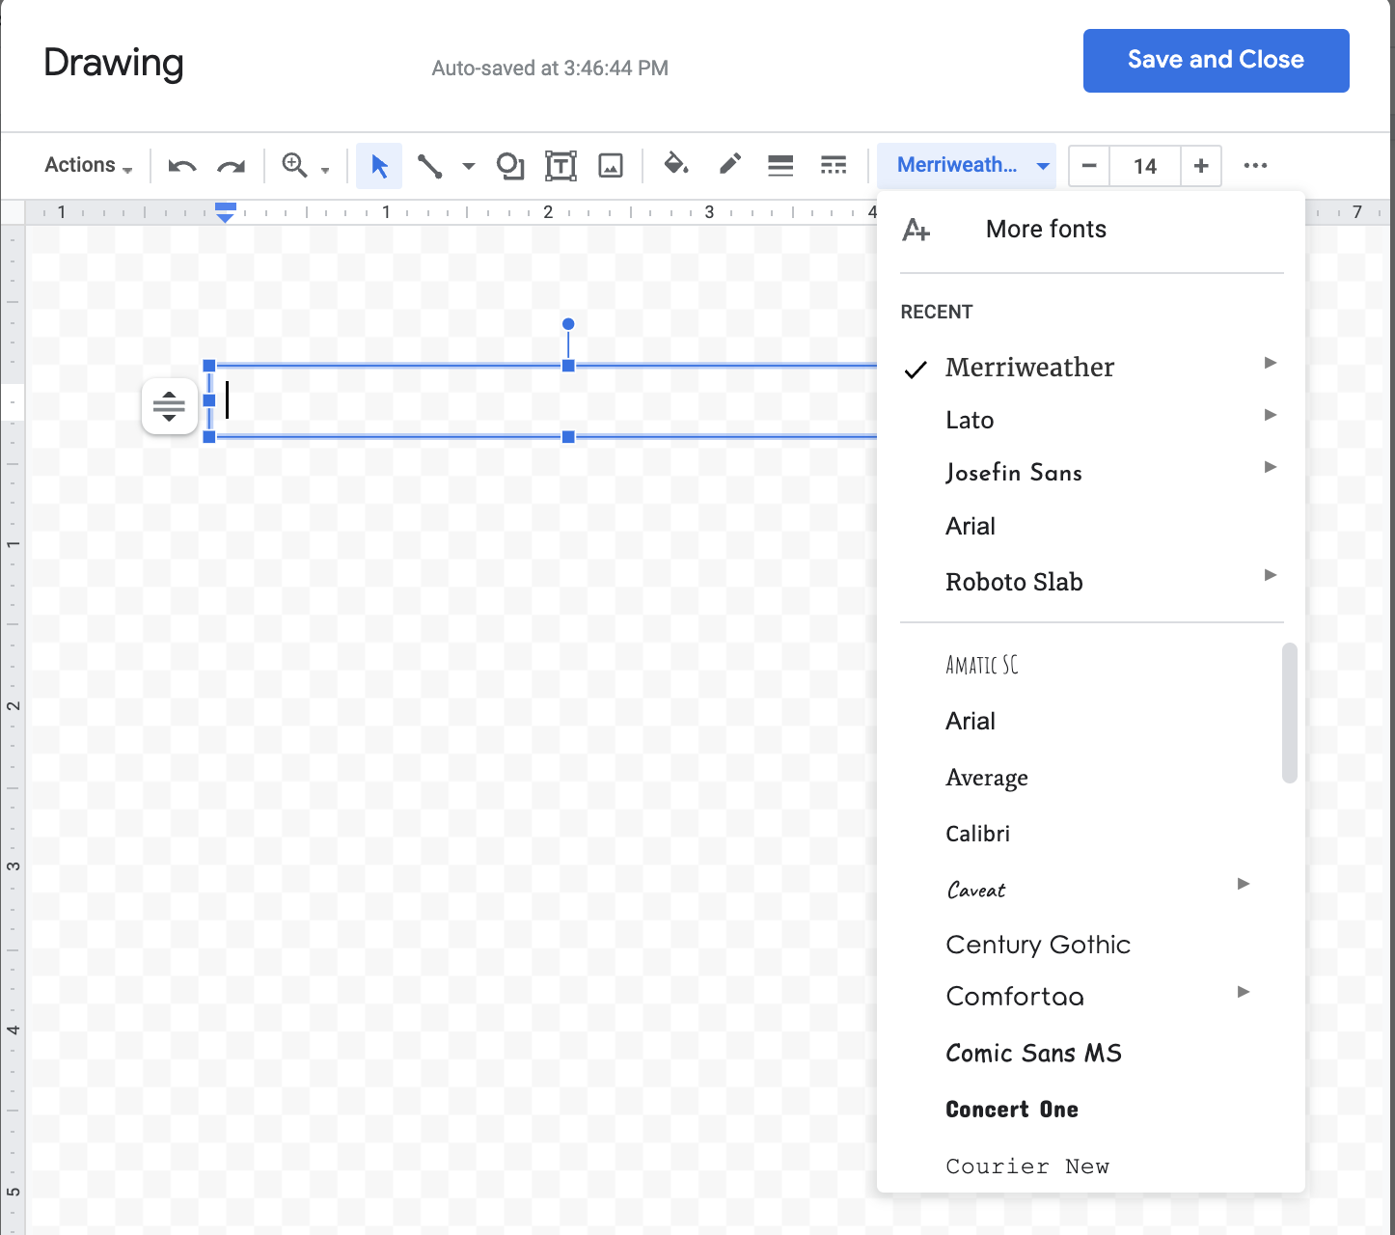
- Now, let’s select a color palette for your logo. Navigate to coolors.co in your web browser. On the main page, select “Explore Trending Palettes” and scroll through the palettes until you find one you like.
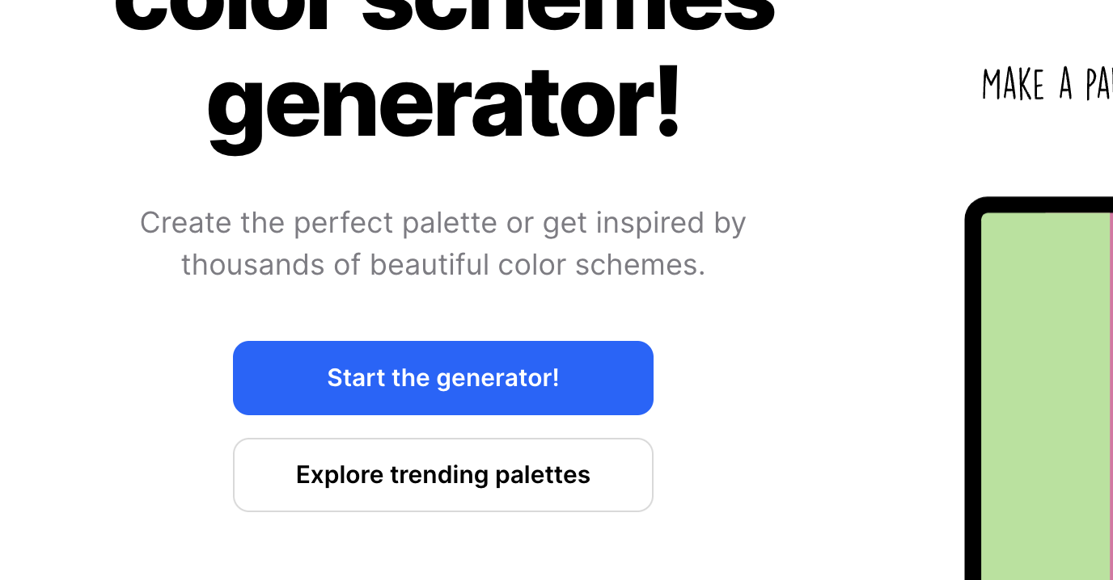
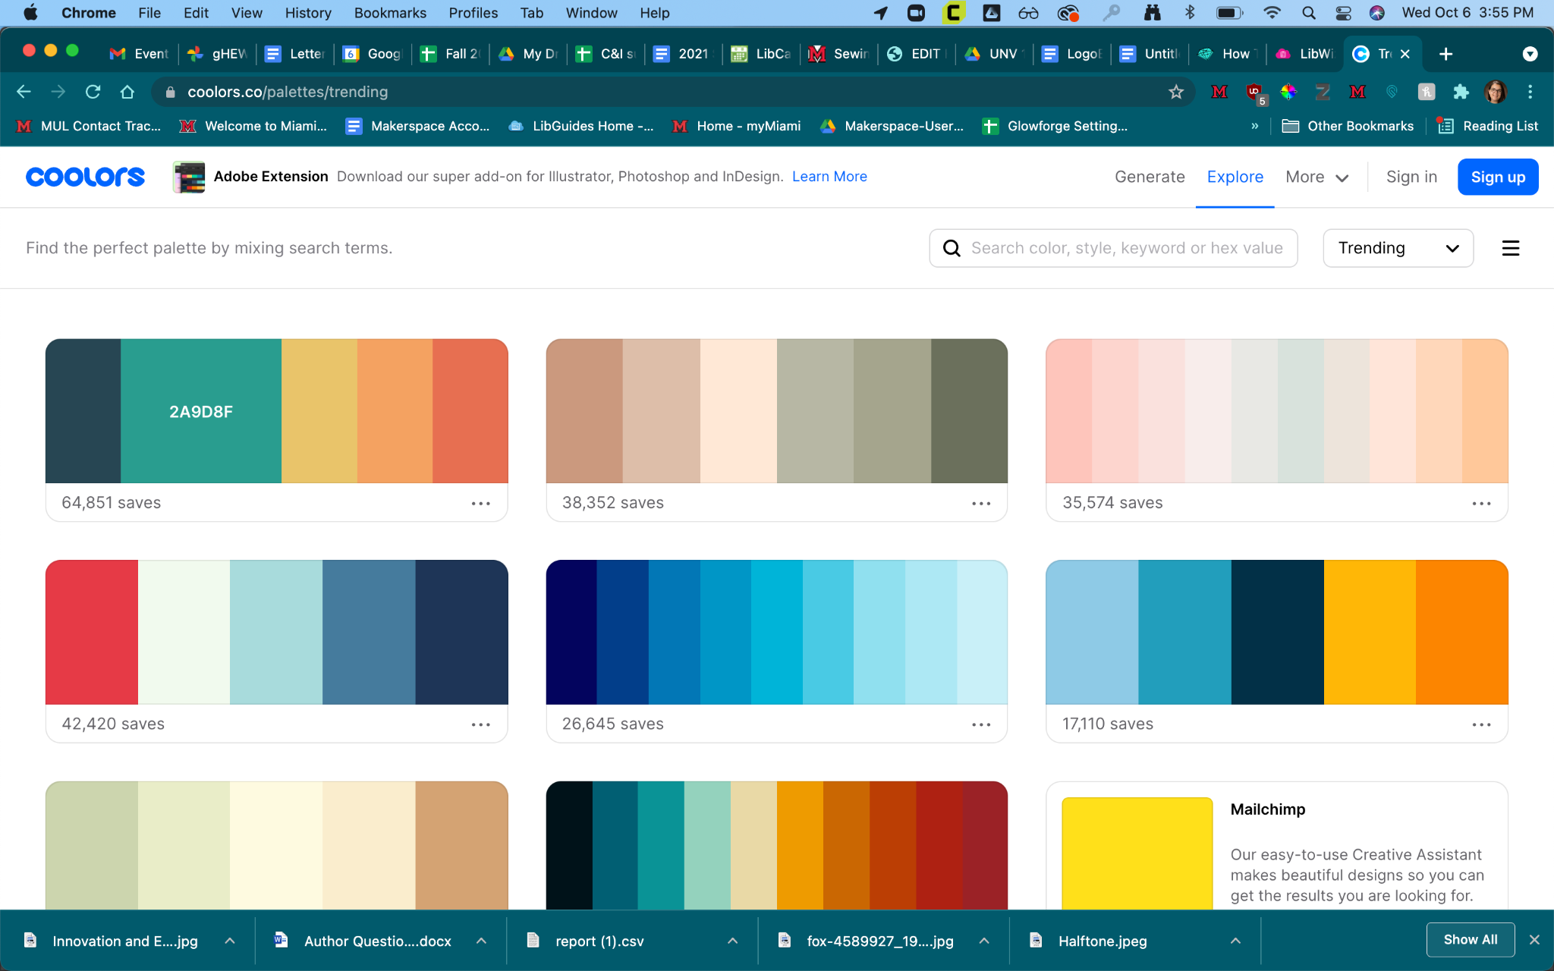

- Hover over a color in a palette, and you will see the HEX code for that color. Click the color, and the HEX code will automatically copy to your clipboard. In your Google Drawing, highlight your text, then select the text color option. In the text color menu, select the “+”.
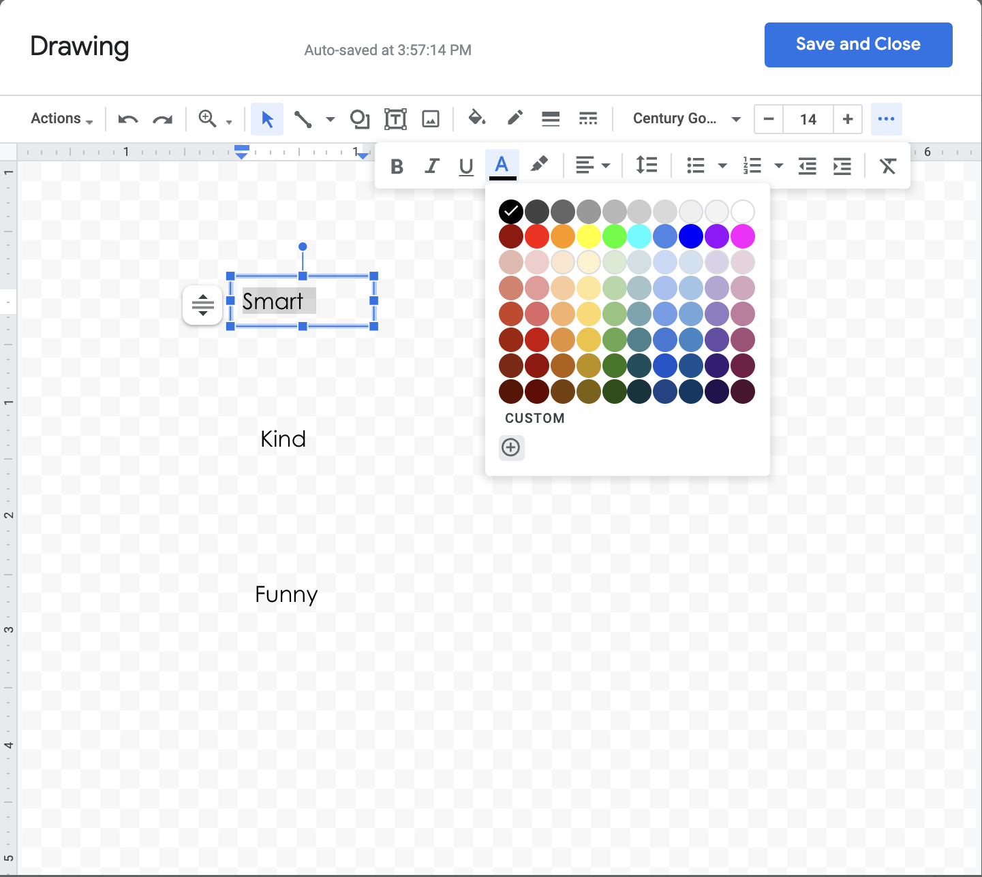
- Paste the HEX code of your desired color into the box, and click “OK”.
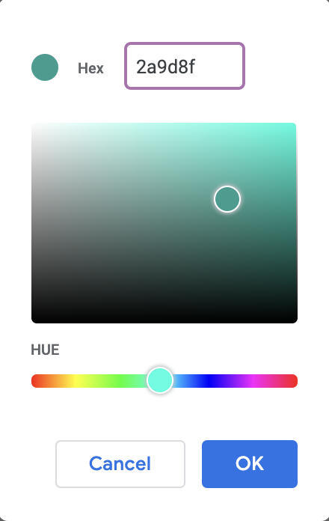

- Repeat this step for each word, using your preferred colors or other colors from the Coolors.co palette. After you color your words, you can play around with size, and other attributes such as Bold, Italics, and Underline.
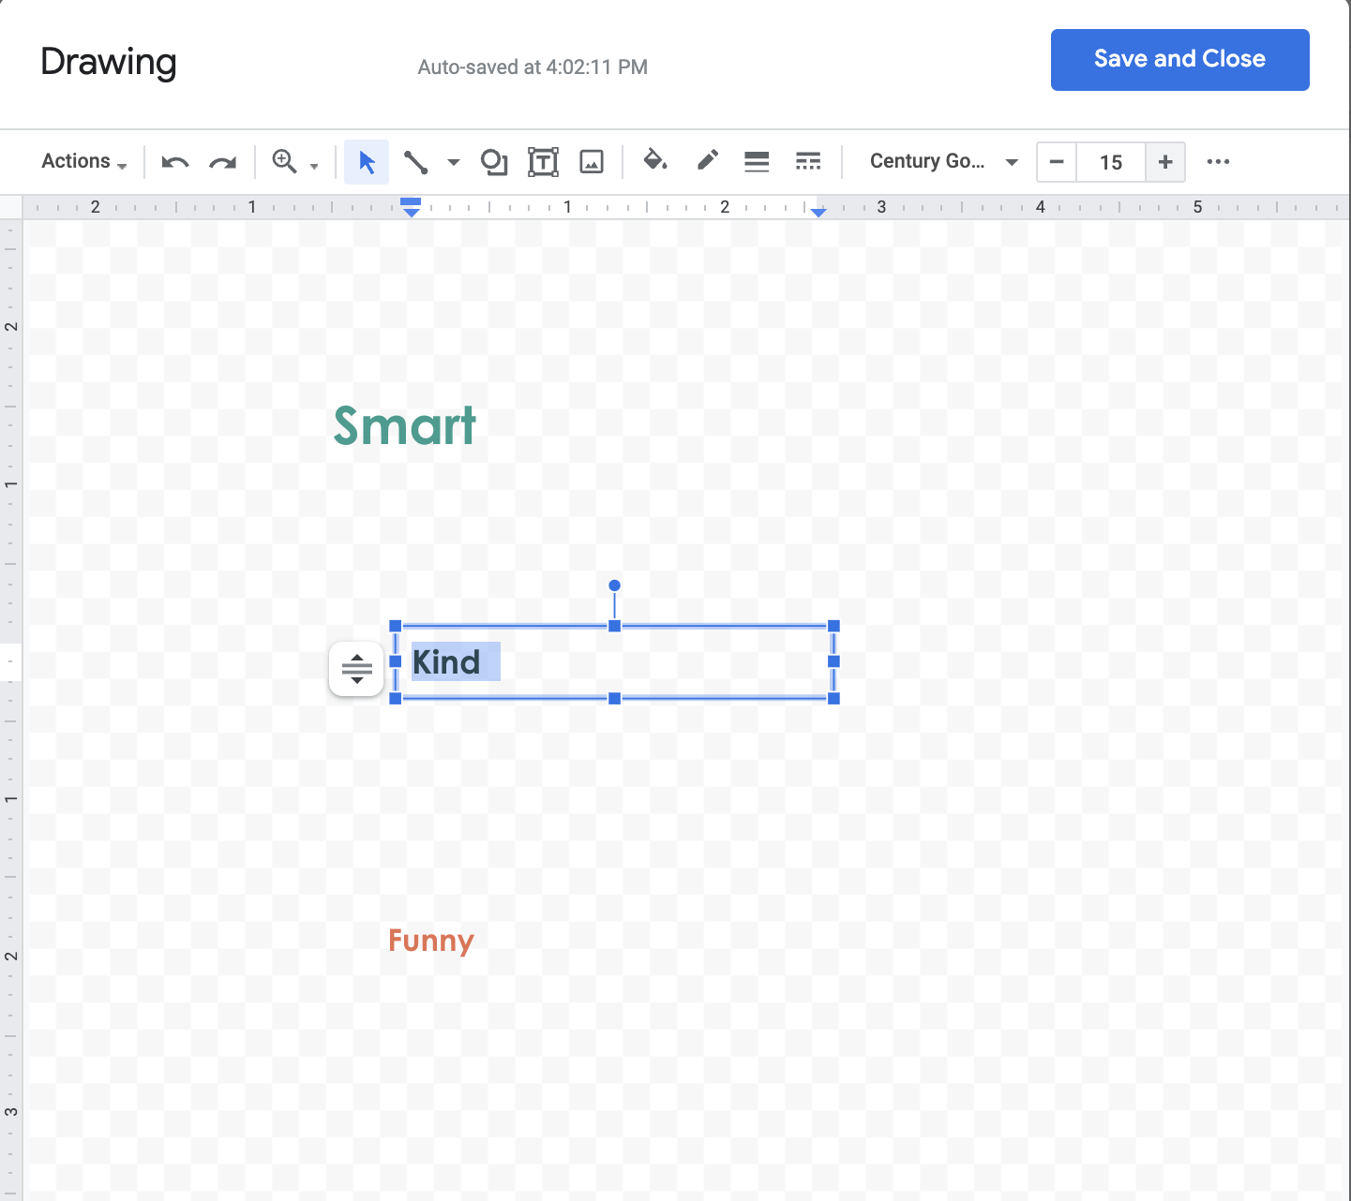

- Now, you will add a graphic element to your logo. In your web browser, navigate to https://www.iconfu.com/ You can search for icons, or browse through until you find one you like. On the left side of the screen, you can choose a color for your icon. Fine a color that fits your color palette.
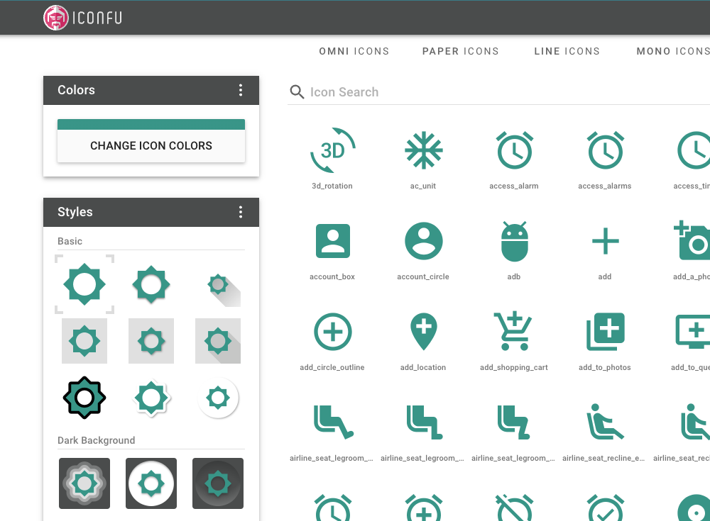
- Click the “Download”. In the following screen, select “1024 px” for size, and “PNG” for file type. Then click “Download” again. The file will download in a .zip file format. On mac, double-click the zip file to unzip. On PC, select the file on your computer, right-click, and select “Unzip”.
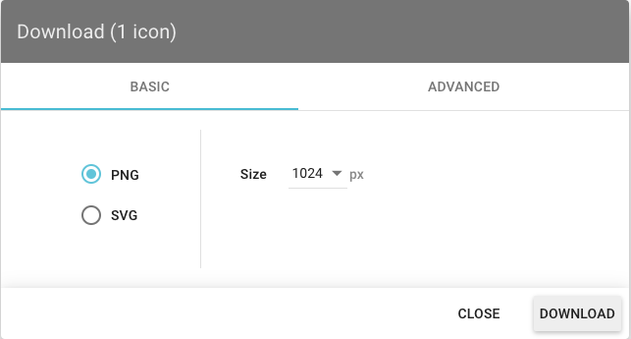
- In Google Drawing, select the icon, and then upload the .png image of your icon. Now, you can resize, rearrange, or rotate the elements of your logo to your liking.
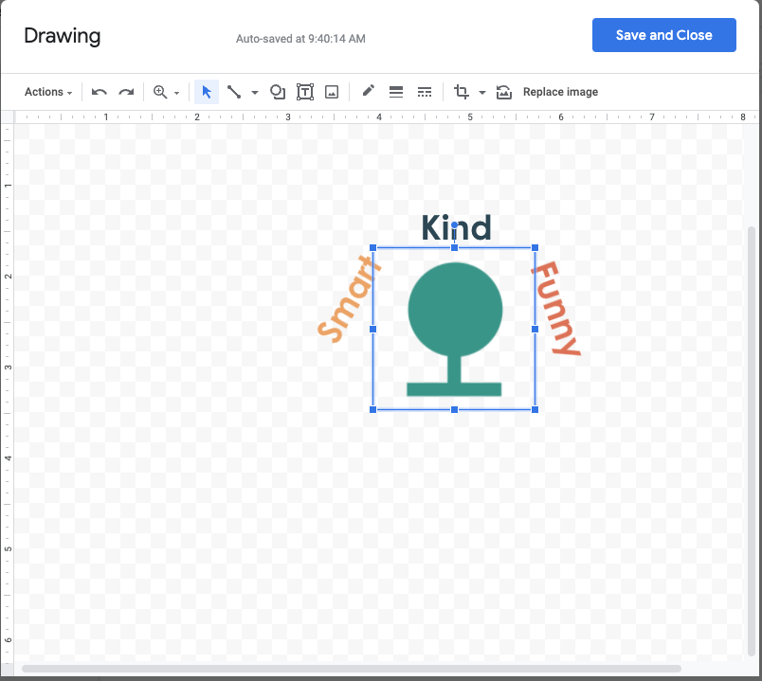
- At this stage, if you’d like to get creative and customize your logo even more, you can use the drawing or shape tools to add or edit elements in your logo.
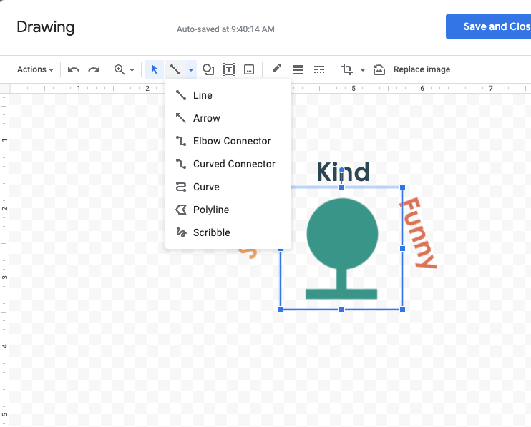
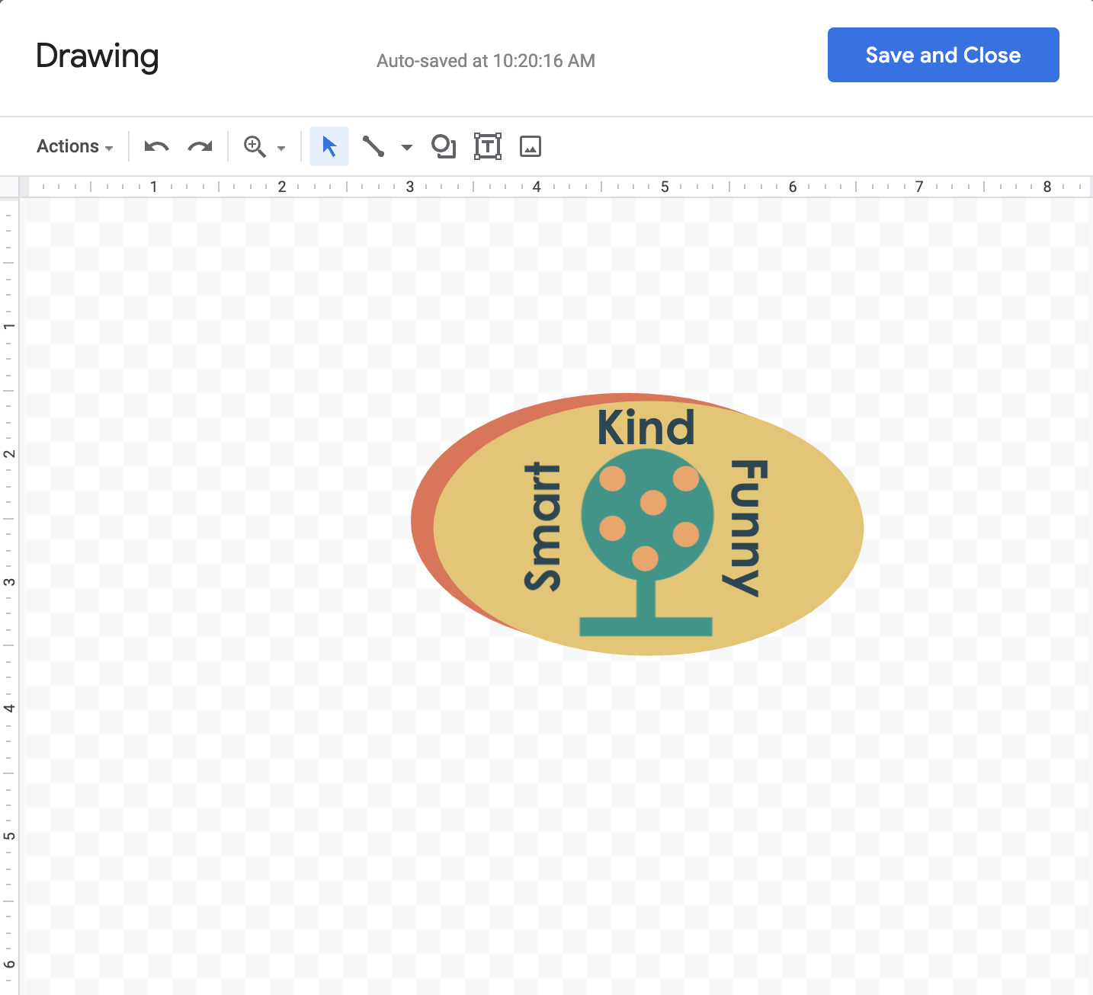
- Now, click Actions -> Download -> Scalable Vector Graphics (.svg) to download your image. Bring your image file into the Makerspace on a flash drive or save it to your Google Drive/email to create your sticker!

